ALGORITHMS OF GEOMETRIC FIGURES IN TURTLE BLOCKS
IN THIS TUTORIAL I WILL SHOW YOU HOW TO MAKE AN ALGORITHM PERFORMED BY GEOMETRIC FIGURES
TURTLE BLOCKS: IT IS AN ACTIVITY IN WHICH WE CAN PROGRAM THROUGH BLOCKS OR PALETTE WITH WHICH MOVEMENTS TO A SMALL TURTLE, WHICH IS ABLE TO PERFORM FIGURES OR ARTS IN PAINTING, THAT SERVES TO BE A VIEW OF WHAT WE ARE PROGRAMING
THIS IS THE TORTUGA BLOCKS PROGRAM:

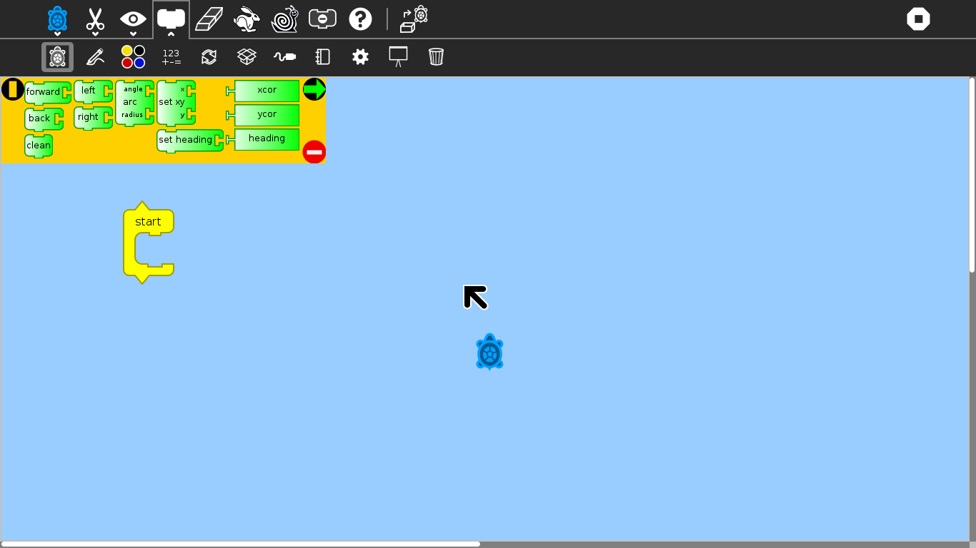

WHAT ARE THE BLOCKS?

Blocks are pieces that are enclosed within a schedule, which

have them together form a functional algorithm that eject the

executed order

HOW TO MAKE FIGURES?

A SQUARE: TO MAKE A SQUARE WE WILL NEED THE BLOCKS OF: "FORWARD" AND "LEFT"

THIS WOULD BE THE PROGRAMMING ...
-FORWARD: 100
-LEFT: 90
-FORWARD: 100
-LEFT: 90
-FORWARD: 100
-LEFT: 90
-FORWARD: 100
-LEFT: 90

WHICH WE CAN ABBREVIATE USING THE "REPEAT" BLOCK AND PUTTING A "4" ON THE SIDE, WITH THIS WE INDICATE THAT YOU REPEAT FOR 4 TIMES THE ACTION

A TRIANGLE: IN THIS FIGURE WE WILL USE THE BLOCKS OF: "LEFT" AND "FORWARD"

THIS WOULD BE THE PROGRAMMING ...
-RIGHT: 120
-FORWARD: 170
-RIGHT: 120
-FORWARD: 170
-RIGHT: 120
-FORWARD: 170

WHICH WE CAN ALSO CURVE USING THE "REPEAT" BLOCK SHOWING A "3"

A CIRCLE: HERE AGAIN WE WILL USE THE BLOCK OF "FORWARD" AND "LEFT"

THIS WOULD BE THE PROGRAMMING ...
-FORWARD: 3
-LEFT: 2

IN THIS FORM IT WILL BE CONVENIENT TO USE THE "REPEAT" BLOCK BECAUSE THE PROGRAMMING IS VERY LONG, THEN WE WILL PUT ON "REPEAT" AND WE WILL TAKE A "200”

WHAT IS A FUNCTION?

IN A FUNCTION WHAT WE DO IS TOGETHER IN A BOX THE PROGRAMMING THAT WE HAVE DONE ABOVE, SO MAKES US AT THE TIME OF FINAL PROGRAMMING

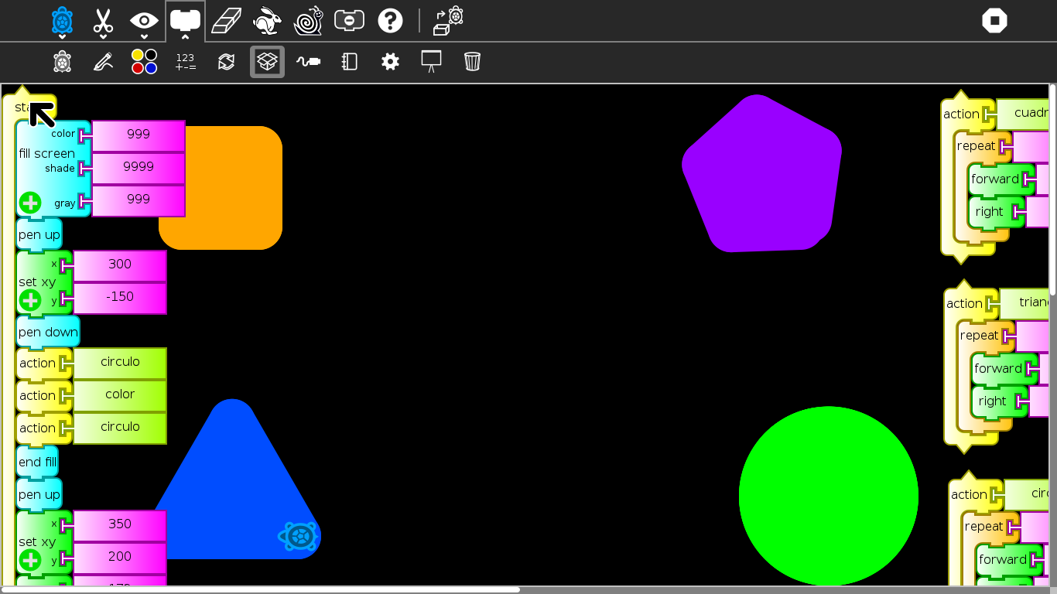
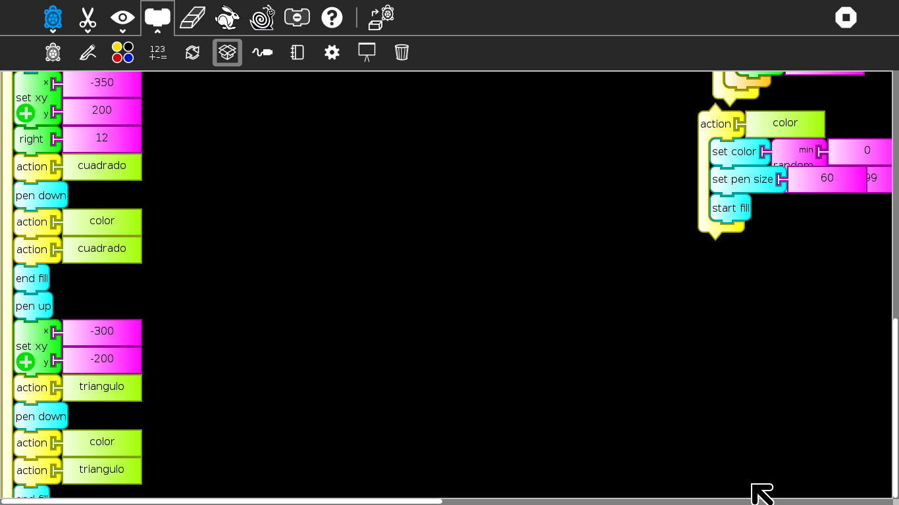
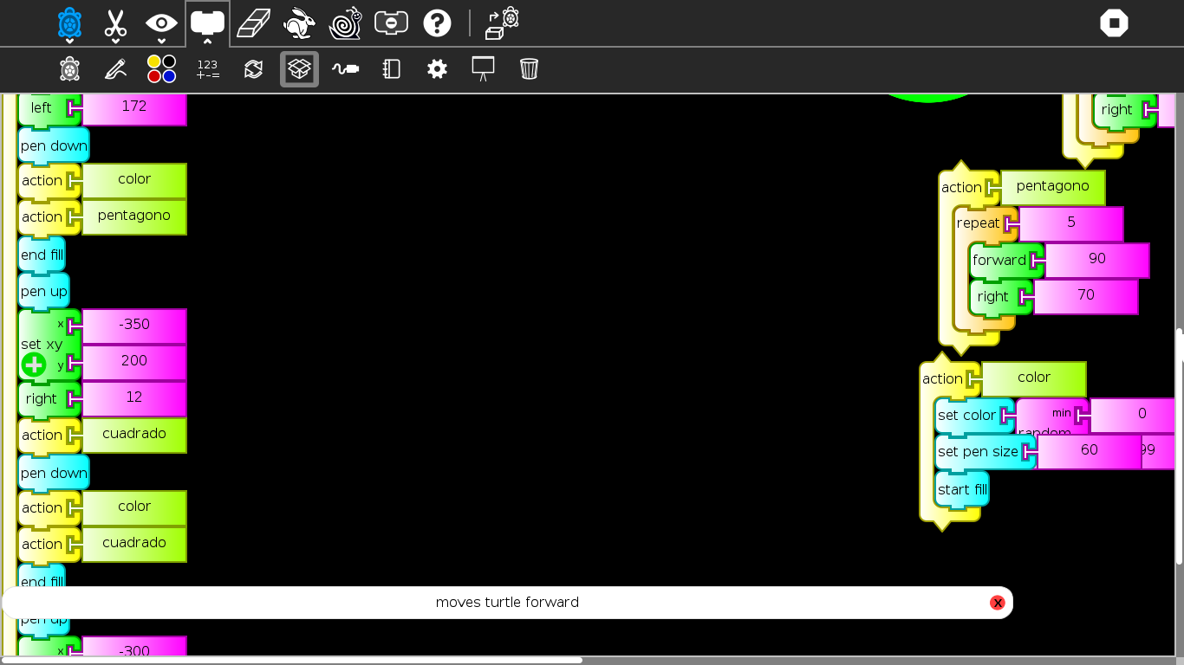

FIRST THAT NOTHING WE HAVE TO FORM THE FIGURES WE WANT, WITHIN THE BOX "REPEAT" WE WILL PUT THE BLOCKS (FORWARD, BACK, RIGHT OR LEFT) ACCORDING TO WHICH FIGURE OR WAY YOU WANT TO DO. BY THE SIDE OF EACH PALLET WE WILL PUT THE DISTANCE OR DEGREE WITH WHICH THE SMALL TURTLE MOVES

EACH FIGURE YOU BELIEVE SHOULD GO WITHIN THE "ACTION" BOX (IMPORTANT)

IN THE FIRST COLUMN WHAT WE DO IS INDICATE THE COLOR TONES FOR THE BACKGROUND OF THE SCREEN (OPTIONAL)

THEN WE CALL TO THE "SQUARE" ACTION (WHICH WE HAVE BEEN PROGRAMMED ABOVE)

AFTER THE "SET COLOR" BLOCK WE CHOOSE THE COLOR WITH WHICH WE WANT TO PAINT THE FIGURE, WITH THE NEXT PALETTE "SET PEN SIZE" WE PUT THE THICKNESS OF THE BRUSH, WITH THE "START FILL" BLOCK WE SAY IT STARTING TO FILL THE FIGURE
THEN WE CALL BACK TO THE "SQUARE" ACTION
AND WE PUT THE PADDLE "END FILL" TO STOP FILLING THE FIGURE

AND WE REPEAT THIS PATTERN FOR ALL ACTIONS ...

WHEN WE EXECUTE THE PROGRAMMING IT SHOULD APPEAR LIKE THIS:

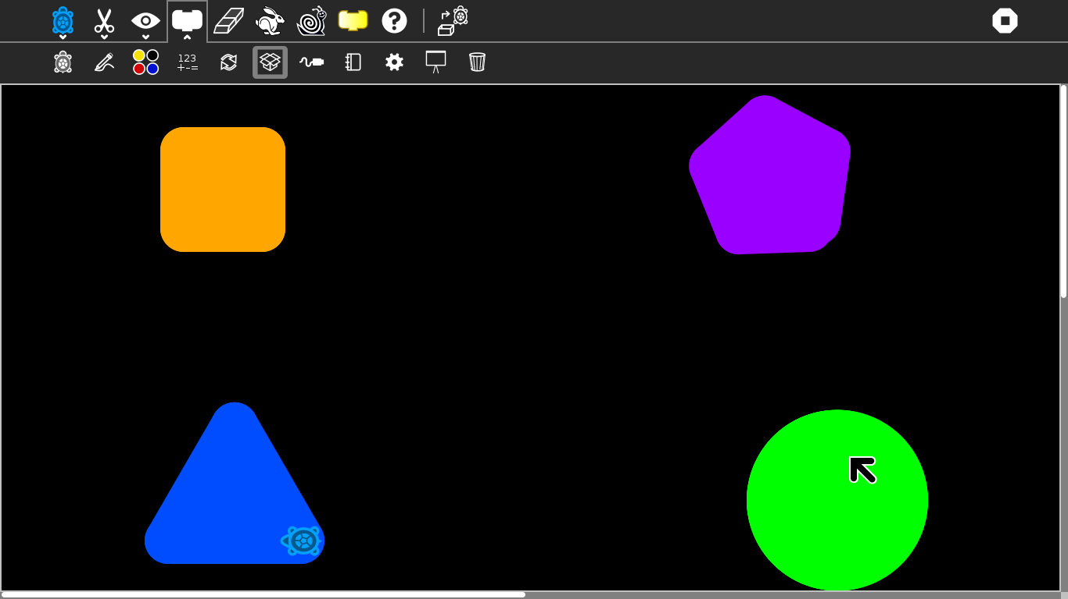

THIS WAS MY SMALL TUTORIAL THAT SERVES THEM OF HELP.

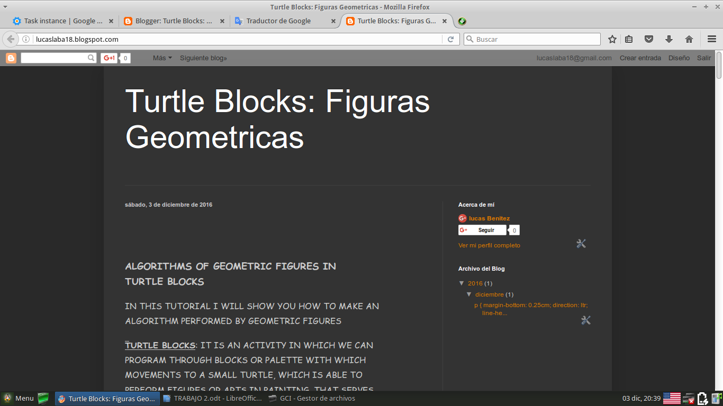
THANK YOU!!!

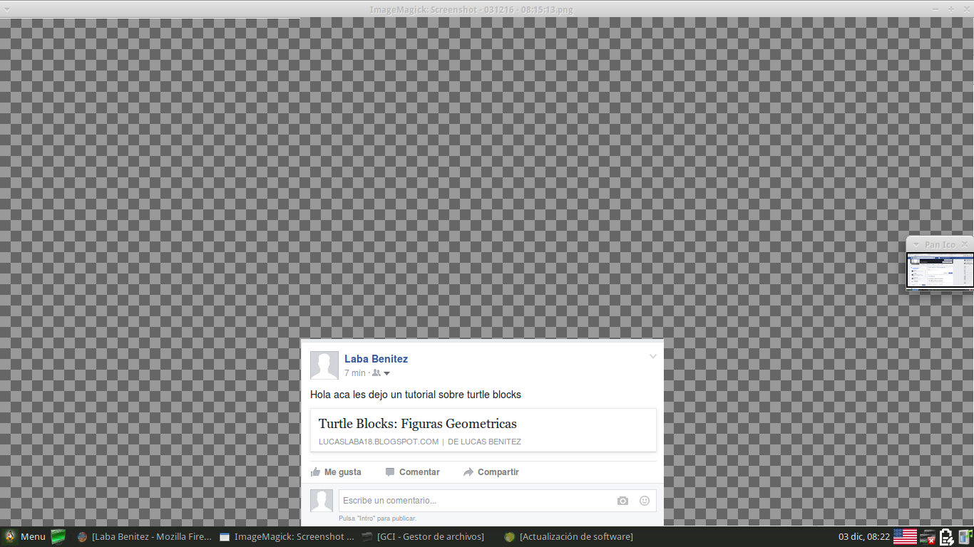

HERE THE SCREEN SHOT OF THE PUBLICATION ON MY SOCIAL NETWORKS

